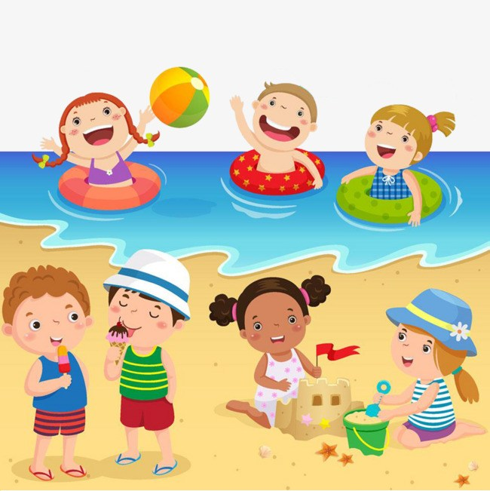 PRE-K HOME LEARNING
CHOICE BOARD
May 25-29, 2020
Choose an activity to do each day. Don’t worry about crossing off the activities after you have finished. You can do these activities multiple times! We will add more activities each week. Just have fun with this! Be sure to look for updates every Monday on your teacher’s website.
Reading | Math | Science | Movement | Creativity
Go along to the beach with Pete the Cat. Enjoy the story: http://www.youtube.com/watch?v=jz6gF8tl6Dk  **********************  "Rainbow fish"  https://www.youtube.com/watch?v=QFORvXhub28  **********************  Listen to The Pout-Pout Fish, then talk about your feelings with your family.  https://www.youtube.com/watch?v=oqupxANpqIE  **********************  “Over in the Ocean”  Read this book and observe all the animals you might see in the ocean!  https://www.youtube.com/watch?v=KBjRBy3SDJ4  **********************  Enjoy this story about a very brave Little fish, who was able to fix a very Big problem with the help of some friends! Retell the story, from beginning, next, then, and end, name all the characters in the story, where it took place, what was the problem, and how was the problem taken care of? How are You like Swimmy?  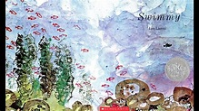https://youtu.be/ZUKJjVXT0Ko  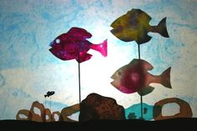  Childrens’ Animated Video of Swimmy, using puppets:  https://youtu.be/4Avs7P16fxg  Retell the story using your own paper puppets that you can make at home.  **********************  Have fun with Gus and Inky on their underwater adventures.  http://www.getreadytoread.org/skill-building-activities/online-games | https://youtu.be/dg0cQtVisLw Practice numbers 1-10 as you sing along with; The Ten Little Fish.  *******************Make an ocean colored squishy bag, then use it to practice writing numbers and making shapes. (Remember to tape the bag closed before using!)  https://www.learning4kids.net/2015/06/30/how-to-make-squishy-sensory-bags/  *******************Make patterns at home with colored goldfish.  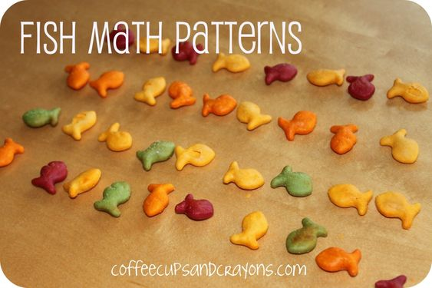  Sort goldfish by color.  hhttps://www.abcya.s/counting_fish  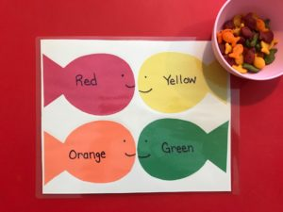  *******************  Count the fish and click the number that matches how many fish you see.  https://www.abcya.com/games/counting_fish  ********************Practice counting from 0-50! Find objects around the house to count. Maybe your family has some seashells that you could sort and count!  ********************Practice recognizing your numbers using your flash cards. Mix them up and name them out of order. I know you can do this! You are smart!  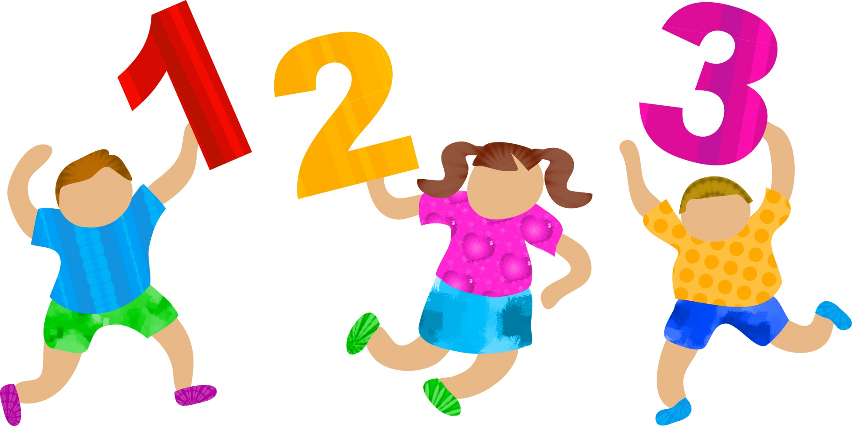 | Sand Play Dough  Mix together 2 cups flour, 1 cup of salt, 1 cup of water and a few drops of vegetable oil. Add 1/2 to 3/4 cups of sand until the dough is a desired texture. ENJOY!  ********************* Listen to the story: All About Sound:  https://youtu.be/oFhda010VH0  Explore underwater sound waves using a bucket a plastic bottle and some water...visit this link to see the experiment: https:// www.stillplayingschool.com/2015/04/sound-under-water-experiment-kids.html  ********************  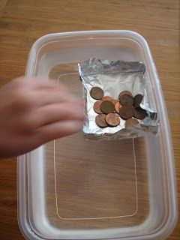  Use tin foil, cups, Legos, or other things around the house to make two boats. Which boat can hold the most pennies (or marbles/ rocks) and still float?  ********************  Wave Bottles  1. Use a funnel to pour a cup full of baby oil (or cooking oil) into a clear plastic bottle.  2. Fill the bottle the rest of the way with water.  3. Give the liquid a chance to settle, then add a few drops of blue food coloring.  4. Add plastic “fish” (sequins), (glue the top on!) and make waves by turning the bottle sideways and rocking it gently.  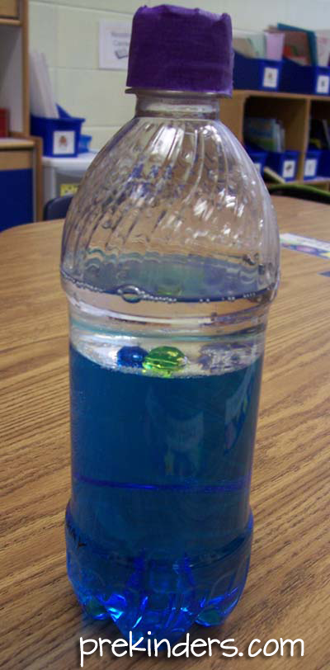 | 5 Little Sand Castles  5 little sandcastles sitting on a beach.  Watching the boats go by. (hand over eyes as though watching boats)  5 little sandcastles sitting on a beach  Watching the seagulls fly (flap arms like a seagull and make the gull noises, too!).  5 little sandcastles sitting on a beach  Watching the clouds so high (look up and point)  When along came a wave (roll hands or make large wave movements with arms)  and washed one away (hold up 1 finger).  Now we are 4 little sandcastles sitting on the beach....  **Repeat the poem and movements down to the last one.  After the last one is washed away:  ...When along came a wave and washed it away.  Now there is nothing to say.  ***  Here is a fun song to get up and dance like a whale have fun!  https://www.youtube.com/watch?v=Parej8Fi0es  ***********************  Dance and sing to these fun and favorite songs:  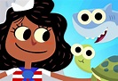  https://youtu.be/nFxAiWkSePk  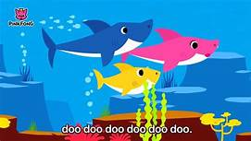https://youtu.be/2dyuEmZLY9Q  ***********************  Listen to this silly beach song 😊  https://www.youtube.com/watch?v=vEZkJhoUI5w  Make up a silly dance to this song and teach it to your family! Have a beach party in the living room!  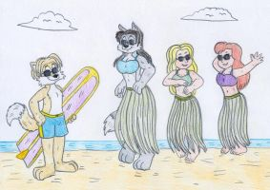 | Here is a fun cute way to make a crab with your child’s hands. Click on the video below. You will need a red paint, a paintbrush, a blue piece of paper and a black sharpie marker.  https://www.youtube.com/watch?v=fsoOoM07I5w  ******************  Here is another cute project on how to make a jellyfish with your child. You’ll need cupcake liners or a cup that you have your child paint, a glue stick, some string or ribbon and a black marker.  https://www.youtube.com/watch?v=c04TrHRBXtc  ******************  After you listen to Rainbow Fish, make your own rainbow fish using a paper plate, tissue paper, glitter, foil, or whatever supplies you have at home.  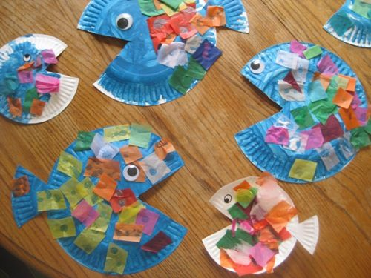  ******************  Are you a pout-pout fish or a kiss-kiss fish? Follow this directed drawing video to draw your own fish.  https://www.youtube.com/watch?v=GJ1CUtSqytE  ******************  Use those cardboard paper tubes to make Swimmy and his friends, using Red & Black paint: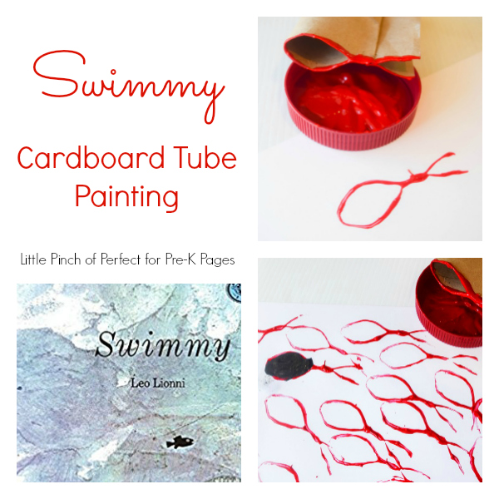https://www.pre-kpages.com/swimmy-the-fish-cardboard-tube-painting/  ******************  Pinterest Sand  Sensory Bin  1 Part Coffee Grounds  2 Parts Flour  Add shells and little fish!  